1. Write a Java program to concatenate a given string to the end of another string

**Input**

class q1

{

public static void main(String args[])

{

String name1="Allah dad";

String name2=" Chachar";

System.out.println(name1+name2);

}

}

**Output**

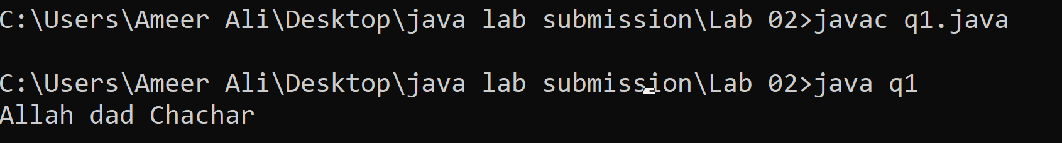

1. Write a program which calculates unit prices on the basis of following conditions

1-100 units price = 5 rupess

101-200 units price = 10 rupees

200-500 units prices = 20 rupees

Units>500 prices = 50 rupees

**Input**

import java.util.Scanner;

class Q2

{

public static void main(String args[])

{

Scanner ip=new Scanner (System.in);

System.out.print("Enter the unit consumed:");

int no=ip.nextInt();

int total;

if(no>=1&&no<=100)

{

total=(no*5);

System.out.print("Total amount is "+total);

}

else if(no>100&&no<=200)

{

total=(100*5)+((no-100)*10);

System.out.print("Total amount is "+total);

}

else if(no>200&&no<=500)

{

total=(100*5)+(100*10)+((no-200)*20);

System.out.print("Total amount is "+total);

}

else if(no>500)

{

total=(100*5)+(100*10)+(300*20)+((no-500)*50);

System.out.print("Total amount is "+total);

}

}

}

**Output**

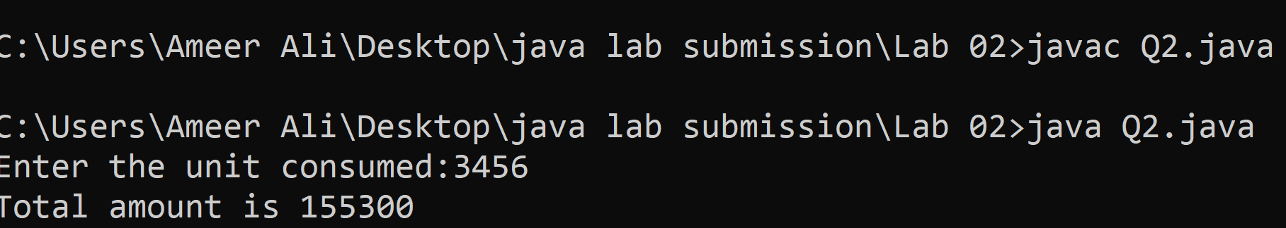

1. Write a Java program to replace each substring of below given sample string
   1. Sample string : "The quick brown fox jumps over the lazy dog."
   2. In the above string replace all the fox with cat

**Input**

class q3

{

public static void main(String args [])

{

String sentence="The dog is very pretty";

System.out.print(sentence.replace("dog","fox"));

}

}

**Output**

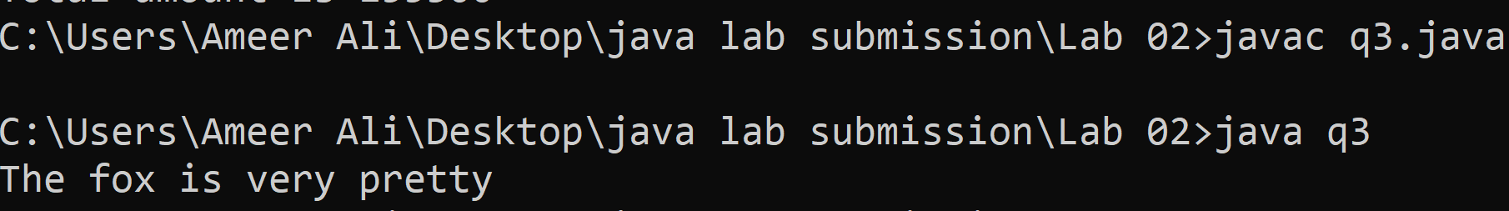

1. Write a Java program which calculate possible notes 1000, 500, 100, and fifty rupees

Enter any number: 6700

Output

Thousands: 6

Five Hundreds: 1

Hundreds : 2

Fifty : 0

**Input**

import java.util.Scanner;

class q4

{

public static void main(String args[])

{

Scanner ip=new Scanner (System.in);

System.out.print("Enter the amount :");

int no=ip.nextInt();

if (no>=1000)

{

System.out.println("One thousand ="+no/1000);

}

int a=(no%1000);

if(a>=500)

{

System.out.println("Five hundred ="+(a/500));

}

int b=(a%500);

if(b>=100)

{

System.out.println("One hundred ="+(b/100));

}

int c=(b%100);

if (c>=50)

{

System.out.println("Fifty ="+(c/50));

}

int d= (c%50);

if(d>=20)

{

System.out.println("Twenty ="+(d/20));

}

int e= (d%20);

if(e>=10)

{

System.out.println("Ten ="+(e/10));

}

}

}

**Output**

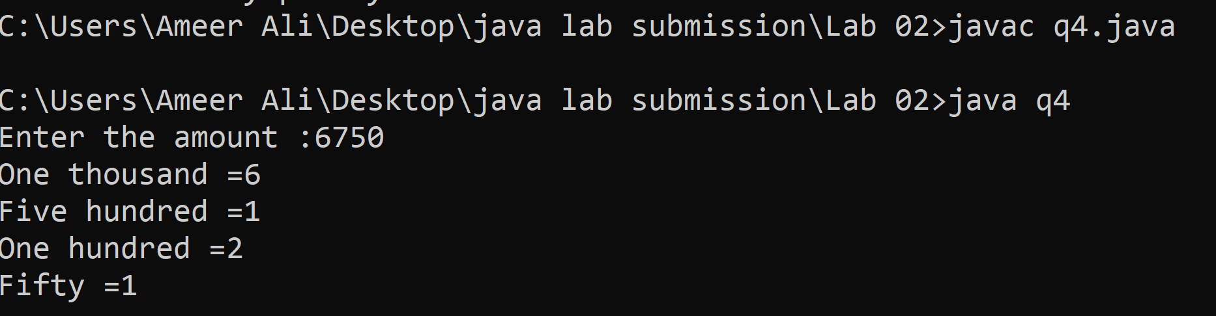

1. Write a program which calculate the factorial of any number.

Enter any number : 4

Output: 24

**Input**

import java.util.Scanner;

class q5

{

public static void main(String args[])

{

Scanner ip=new Scanner (System.in);

int total=0;

System.out.print("Enter the number to check it,s factorial:");

int no=ip.nextInt();

for(int i=no-1;i>=1;i--)

{

total=total+(no*i);

}

System.out.print("factorial="+total);

}

}

**Output**

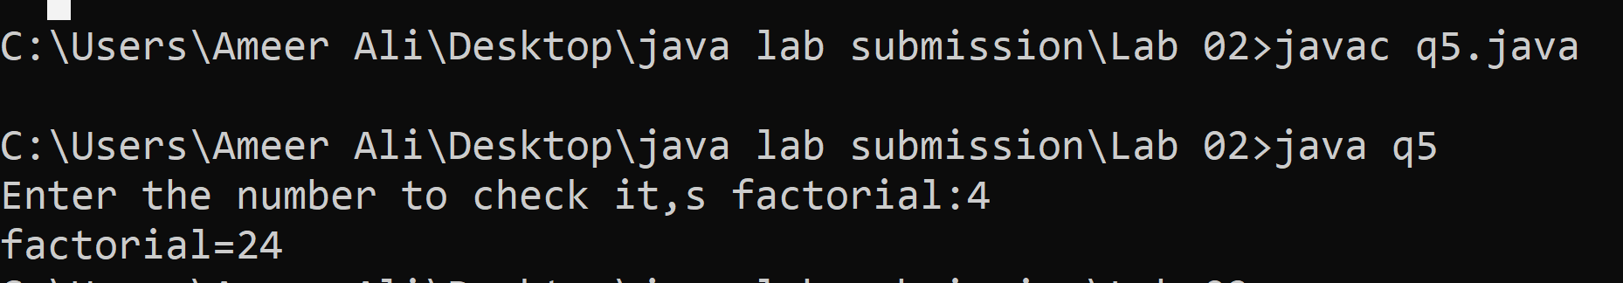

1. Write a program which calculate total characters,and words in the string

Enter any string: Asif Ali

Total words: 2

Total characters: 8

**Input**

import java.util.Scanner;

class q6

{

public static void main(String args[])

{

Scanner ip=new Scanner(System.in);

System.out.print("Enter any string :");

String Sentence=ip.nextLine();

int count=1;

System.out.print("Total Characters "+Sentence.length());

for(int i=0;i<Sentence.length();i++)

{

if (Sentence.charAt(i)==' ')

{

count++;

}

}

System.out.print("Total words :"+count);

}

}

**Output**

